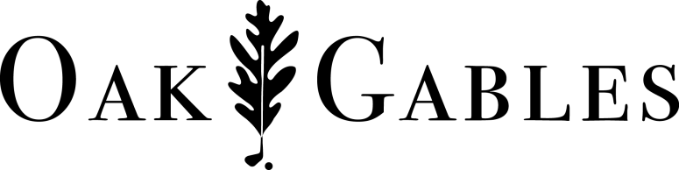
2018 Ross Golf Academy

NAME:_____________________________________________________ Birthday:_________________
ADDRESS:
CITY: POSTAL CODE:
PHONE: E-MAIL:
CATEGORIES & RATES – please check appropriate box
Spring Clinics $125 (Members $80) |  | Summer Camps $380 (members $235)
Ages 6/7 Saturdays 9:00-10:00am |  | July 3-6 *(4 day Mini Junior)
Ages 6/7 Sundays 9:00-10:00am |  | July 9-13
 |  | July 16-20
Ages 8/9 Saturdays 10:30-11:30am |  | July 23-27
Ages 8/9 Sundays NOON-1:00pm |  | July 30-Aug 3
 |  | August 7-10 * (4 day Mini Junior)
Ages 10/11 Saturdays NOON-1:00pm |  | August 13-17
Ages 10/11 Sundays 10:30-11:30am |  | August 20-24
 |  | MEMBERSHIPS
Ages 12+ Saturdays 1:30-2:30pm |  | Junior Membership $425
Ages 12+ Sundays 1:30-2:30pm |  | Junior Range Membership $160
- All spring clinics start May 26/27 thru June 23/24
- 5 week program
- Mini Junior weeks are for ages 6-9
- 4 day camps $310
Rates :
- All camp and clinic participants will receive 2 complimentary 9 hole Green fees
- Taxes included in all pricing

Call in Payments or Mail to:
Oak Gables Golf Club 1505 Hwy #2 – Jerseyville, ON L0R 1R0
Phone: (905) 648-4653 admin@oakgables.com

Please do not send your card # by mail – phone or fax it in. Security by mail cannot be guaranteed.
- VISA Card # ________________________ Cardholder Name: _________________
- MASTERCARD Expiry _____/_____
- CHEQUE ⁯ CASH
SEE REVERSE . . . PLEASE READ CAREFULLY
Members must sign waiver release and indemnity agreement
PERSONAL PROPERTY
The Club is not responsible for the loss or theft of, or damage to, personal property on the Club’s premises whether held in storage or not. This includes, but is not limited to, golf clubs, golf bags, golf accessories, money, or other property. The Member will take all precautions to avoid loss or theft of or damage to personal property. In the event of such loss or damage, the Member agrees to hold the club harmless from and against any and all claims, actions, cost, expenses and demands in respect to such theft, loss or damage however caused arising out of or in connection with the use of the Club
POWER CART
The member agrees to assume all risk of loss or damage to motorized golf carts rented or borrowed from the club as well as the risk of injury to the Member or other persons and damage to other property arising from the use of the golf cart. The Member will take all precautions to avoid loss or damage to the golf carts, damage to other property and injury to persons including to the Member arising out of the use of golf carts. In the event of any loss, damage, or injury, the Member agrees to hold the Club harmless from and against any and all claims, actions, costs, expenses, and demands in respect of such loss, damage or injury, however caused.
The Member agrees to indemnify and reimburse the Club for any liability, cost or expense imposed by law upon the Club for any and all such losses.
GENERAL WAIVER
The Member acknowledges that there are risks inherent in participation in the game of golf. The Member agrees to release the Club from any liability from personal injury, property damage or loss sustained by the Member, including injury resulting in death and any financial loss or damage directly or indirectly resulting from Members’ activities or participation in events at the Club. The Member further waives, as against the Club, all claims recourses and rights of action that the Member may have against the Club as a result of persona injury, property damage or loss.
The Member agrees that this waiver, release and indemnity agreement shall not be affected by any negligence, gross negligence, breach of contract or any other conduct on the part of the Club.
The Member acknowledges that he or she has read the waiver, release and indemnity agreement and understands and accepts the contents hereof.
In the event that any provision herein contained is deemed to be unenforceable and/or invalid, then the provisions shall be severable from the whole of the document and shall not affect the validity and enforceability of the other provisions and the document as a whole.

Guardian Signature: _____________________________________ Date: _________________
My signature indicates that I have read and am in agreement with the above statements.

